GIFTS ONLINE CATALOGUE

1. *CAKES*

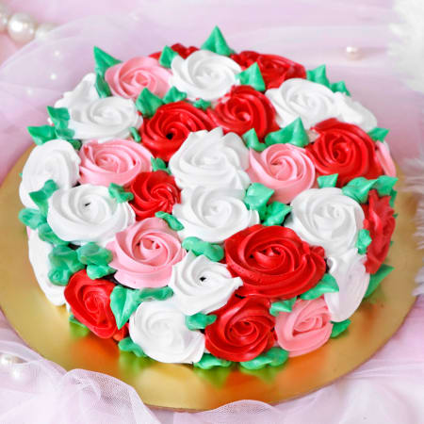

1. ROSES CAKE .

1KGS: 1000KSH

HALF KG: 500KSH

SLICE: 250KSH

. Red Velvet cake

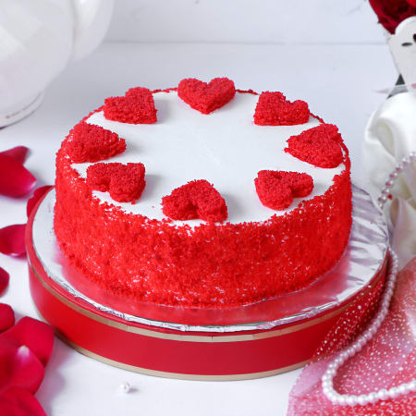



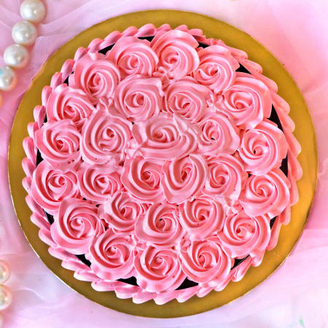



*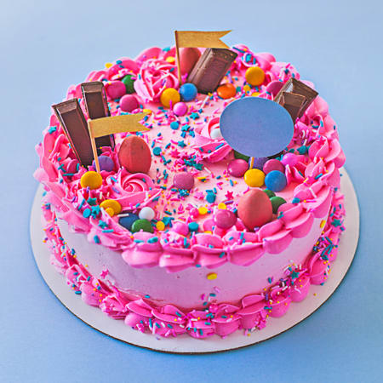*

*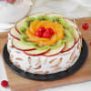*

*2.JEWLERY.*

*a.) Men Jewlery*

*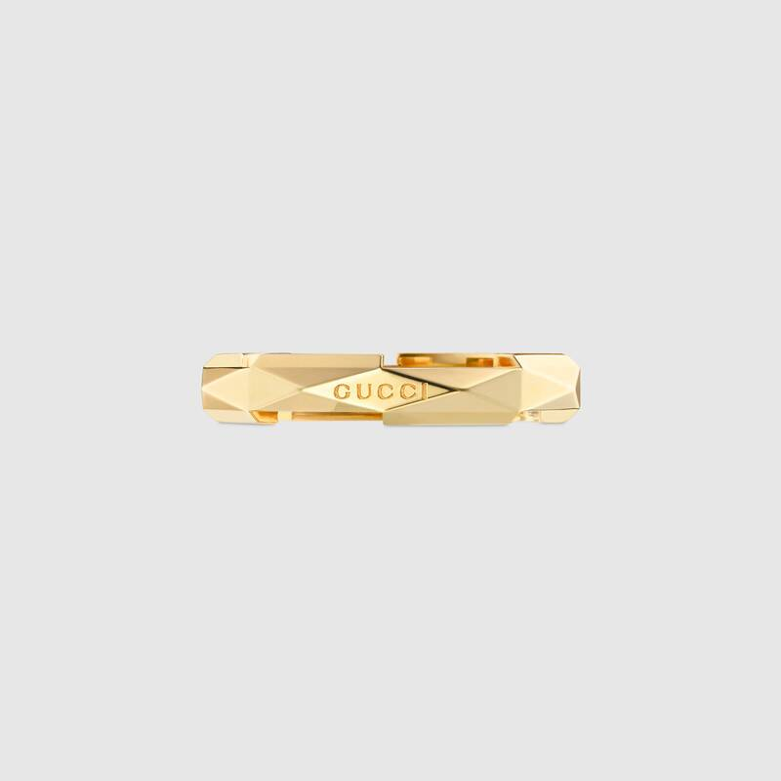*

Studded Ring

*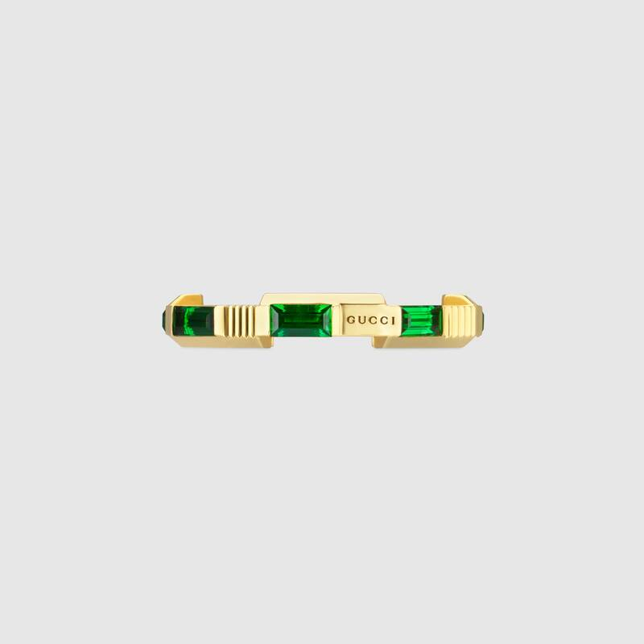*

tourmaline-ring

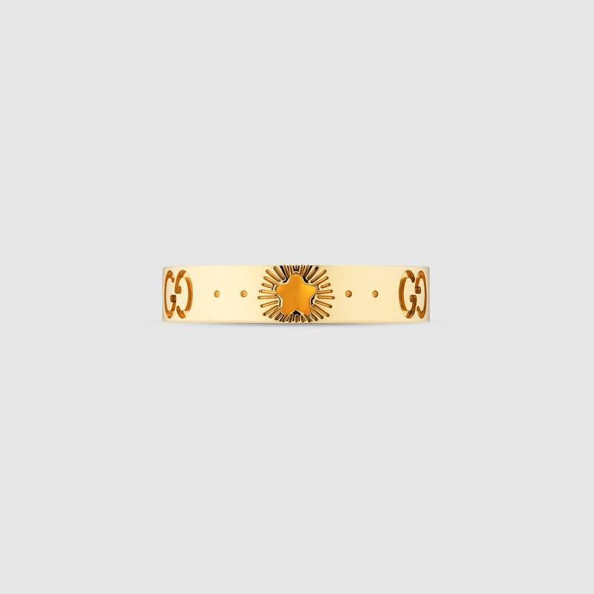

Light yellow gold ring

*Ladies Jewelry.*

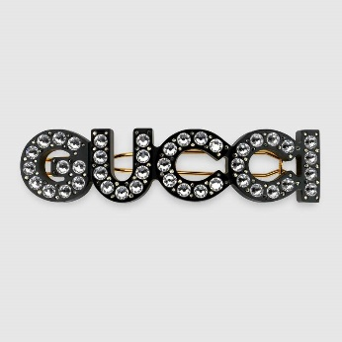

1. Gucci hair slide

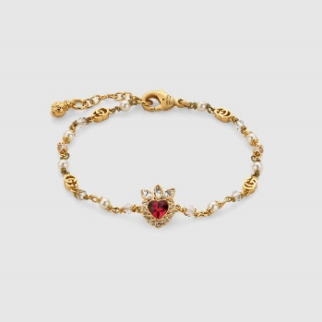

1. Gucci heart Bracelet

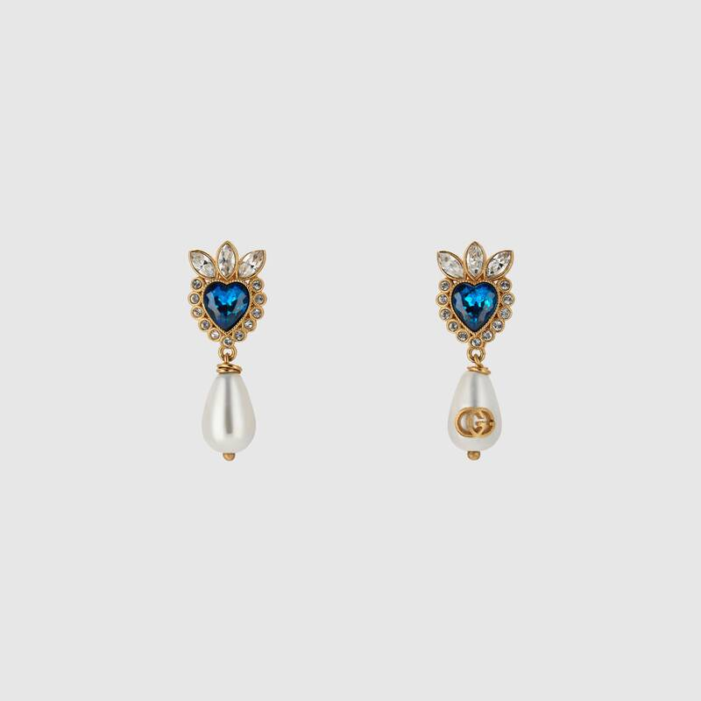

1. Gucci Light heart earing

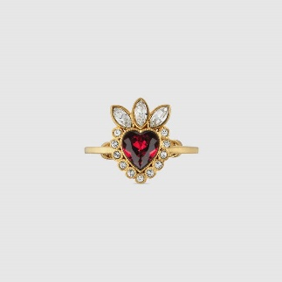

1. Gucci Light heart ring

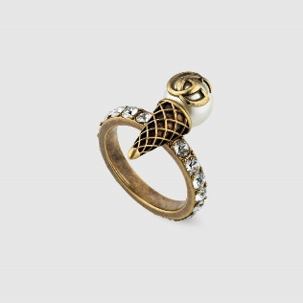

1. *Double-G-ice-cream*

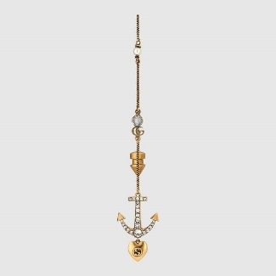

1. *Drop earing with anchor*

*4. PERFUMES*

*1. Men Perfumes*

*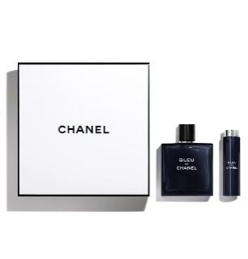*

1. bleu-de-chanel-5-fl-oz-eau-de-toilette-twist-and-spray

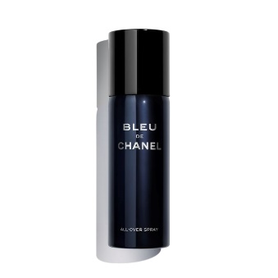

1. bleu-de-chanel-all-over-spray

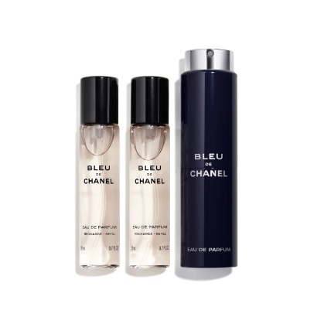

3. bleu-de-chanel-eau-de-parfum-twist-and-spray

*Women Perfumes*

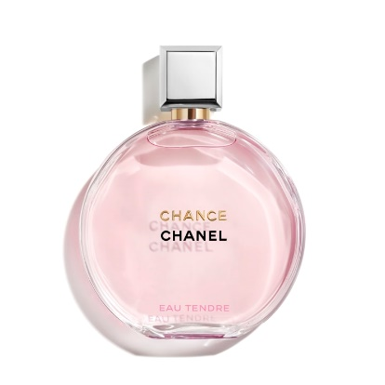

1. chance-eau-tendre-eau-de-parfum-spray

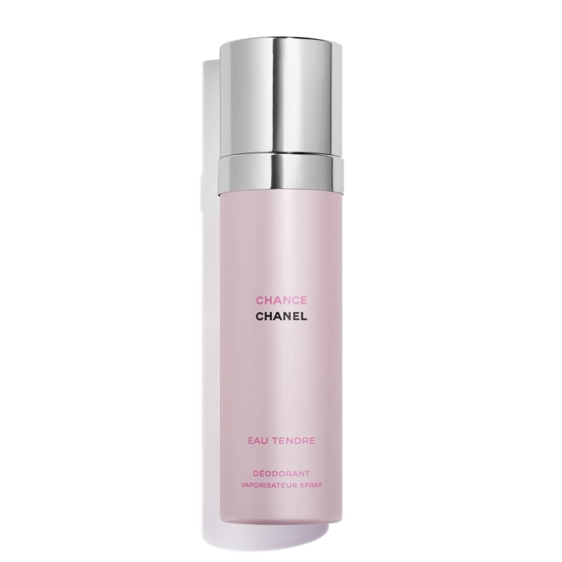

1. chance-eau-tendre-deodorant-spray

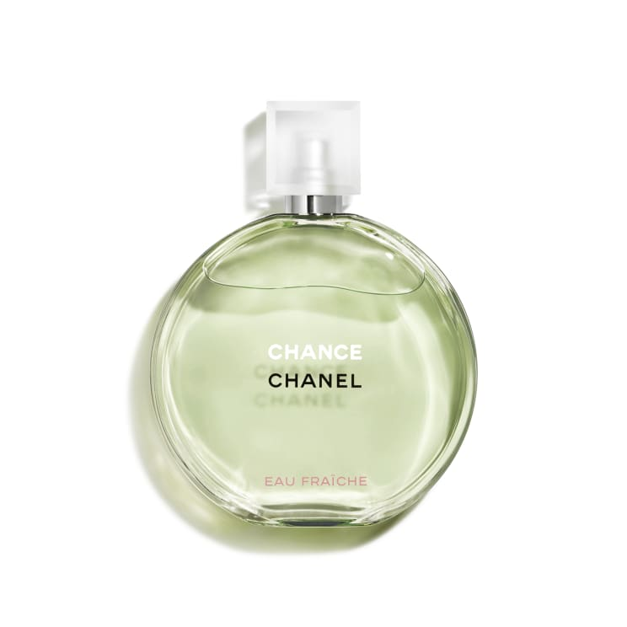

1. flacon-EF-V2

GUCCI PERFUMES

*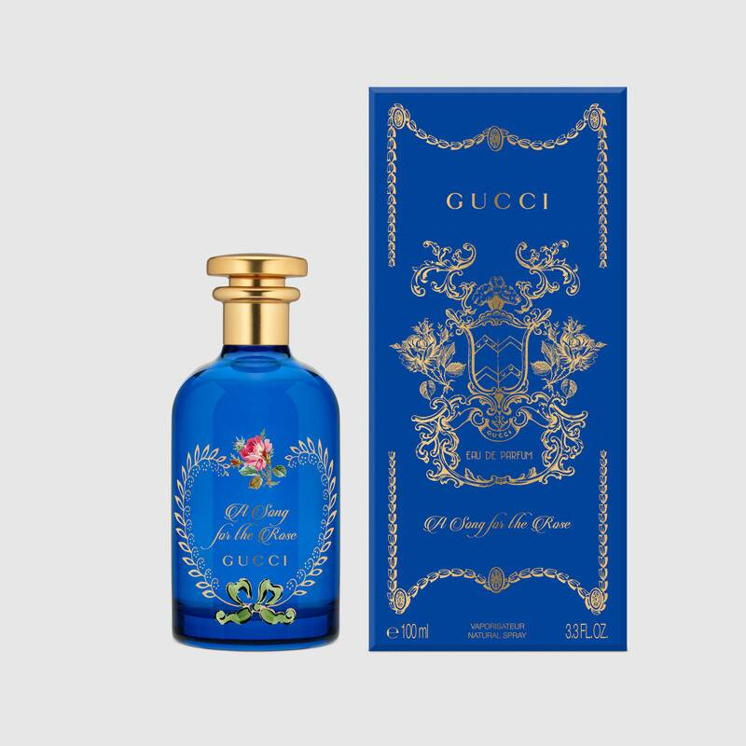4.A song of the rose*

*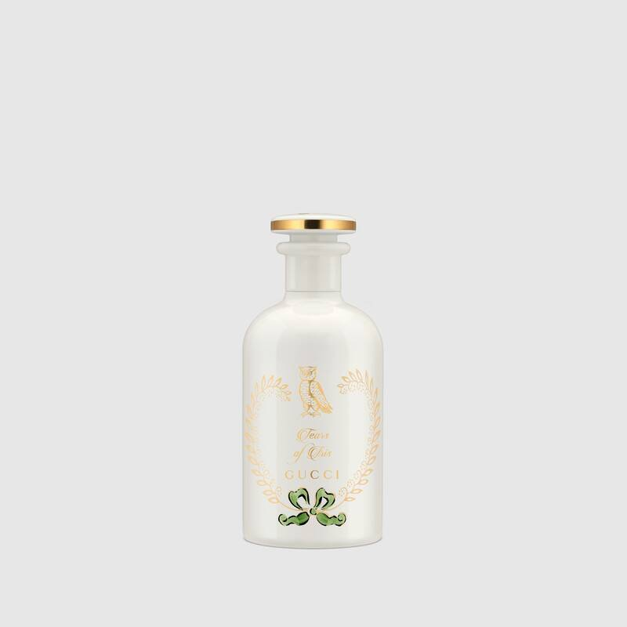5.Tears of Iris*

*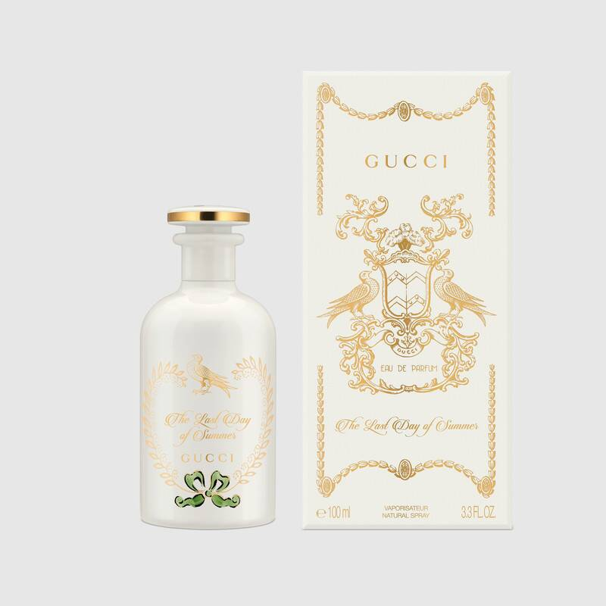 6. The Last day of Summer woods*

*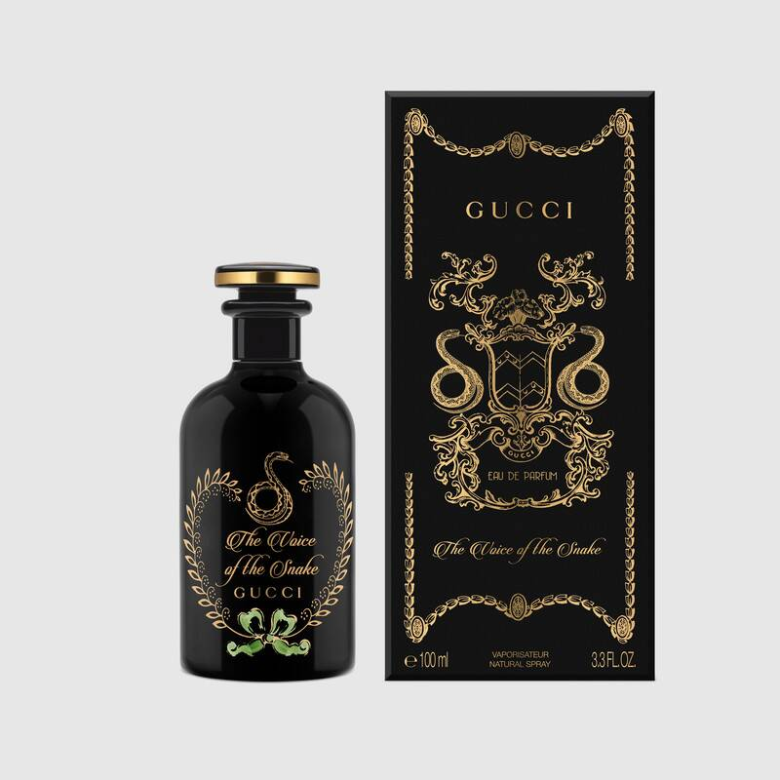7. The voice of Snake Oud.*

*A powerful and captivating scent, Oud is combined with Patchouli and notes of Saffron for an intense, woody fragrance that captures the mysterious and hypnotizing nature of the snake.*

*Accentuate this fragrance by layering it with perfumed oils and acque profumate from the collection to create a personalized blend.*

1. *DESIGNER BAGS   
   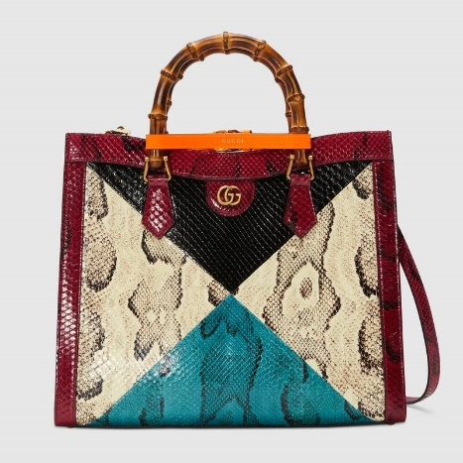 1. Gucci Phyton tote bag.*

*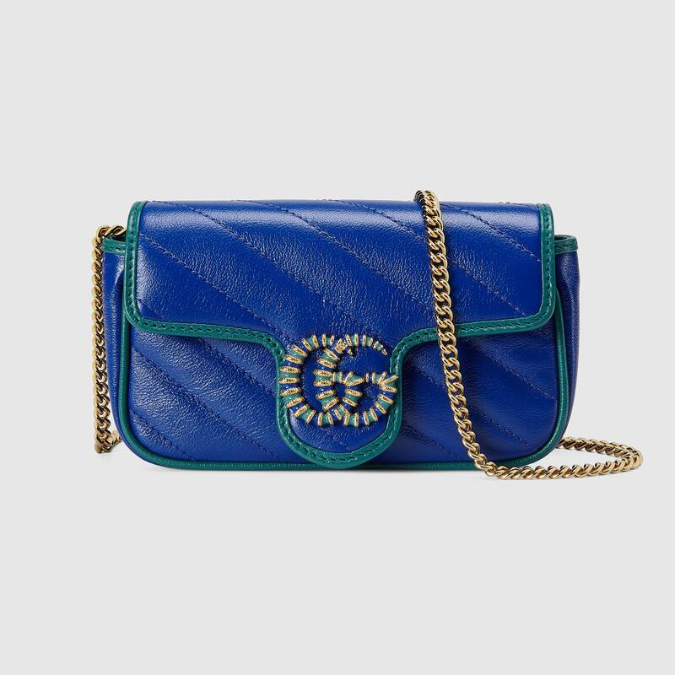2. Gucci Light Marmont supermini bag.*

1. *WATCH.*
   1. *CHANEL*

*J12 ELECTRO DREAM WATCH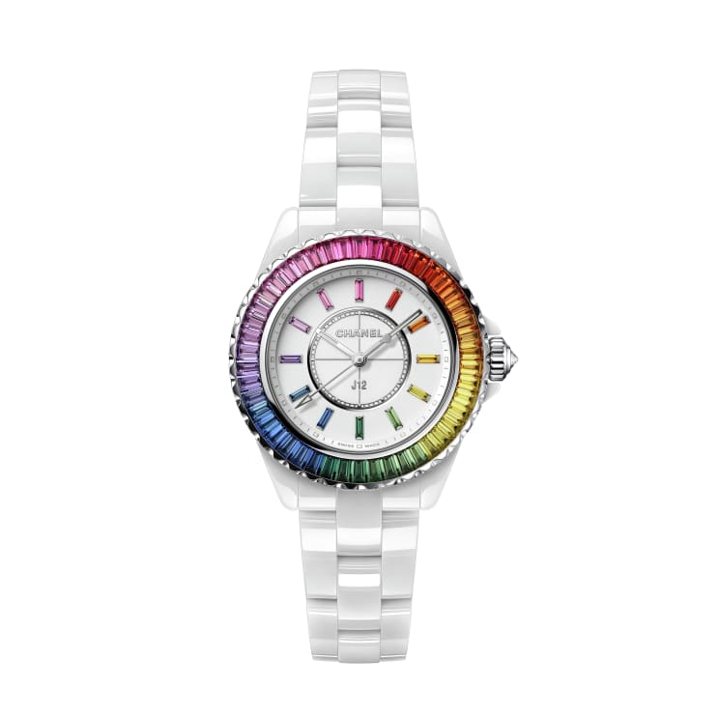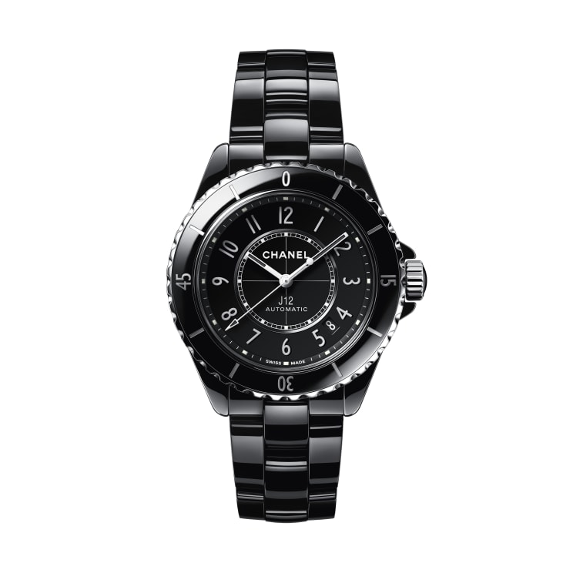 2. J12 CALIBER WATCH*

*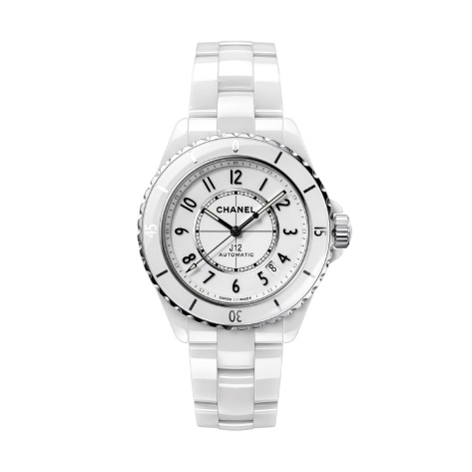3. J12 CALIBER WHITE CREAM*

*4. CAMELIA SKELETON WATCH BLACK DIAMOND*

*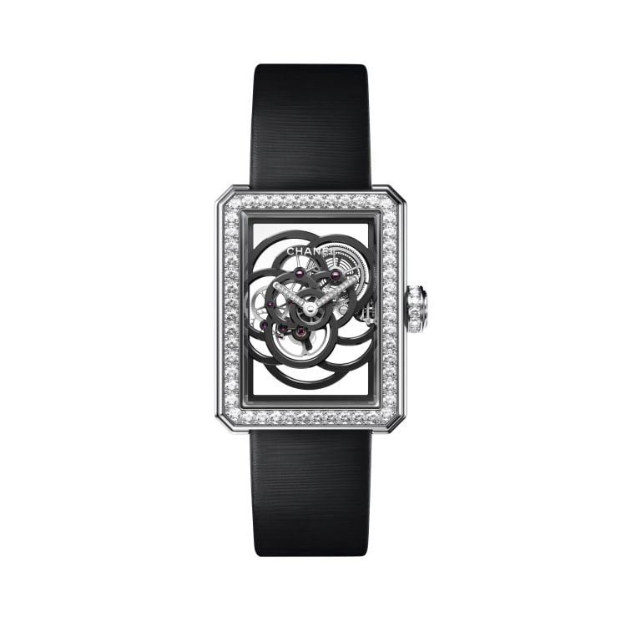*

1. *GLASSES:*
   1. *CHANEL*

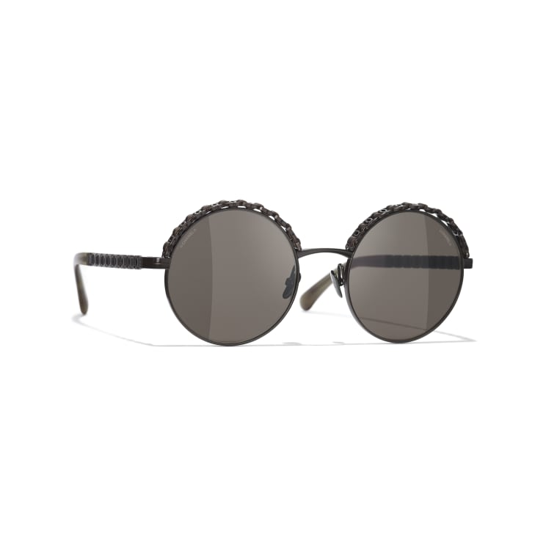*1. Round Sunglasses*

*- Made with brown metal Calf skin.*

*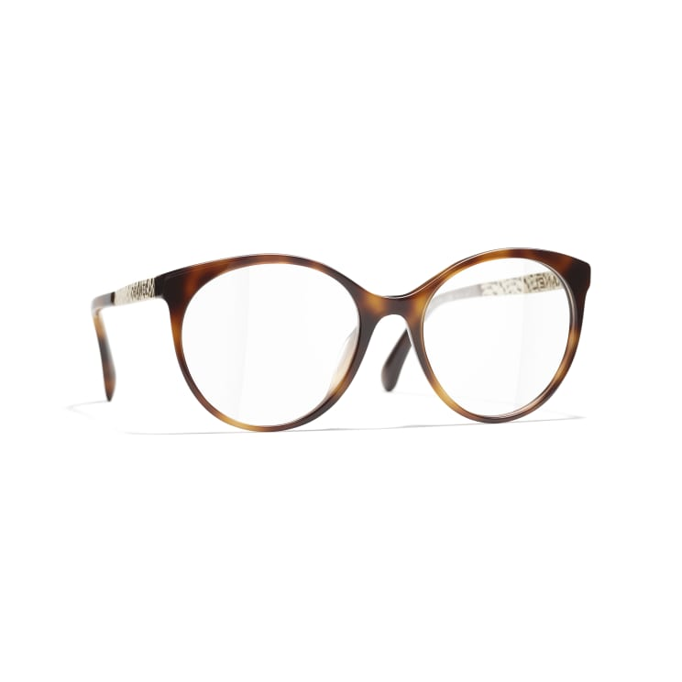2. Pantos eyeglases*

*Pantos eyeglases, tortoise acetate metal packshot is idea for both casual and formal looks*

*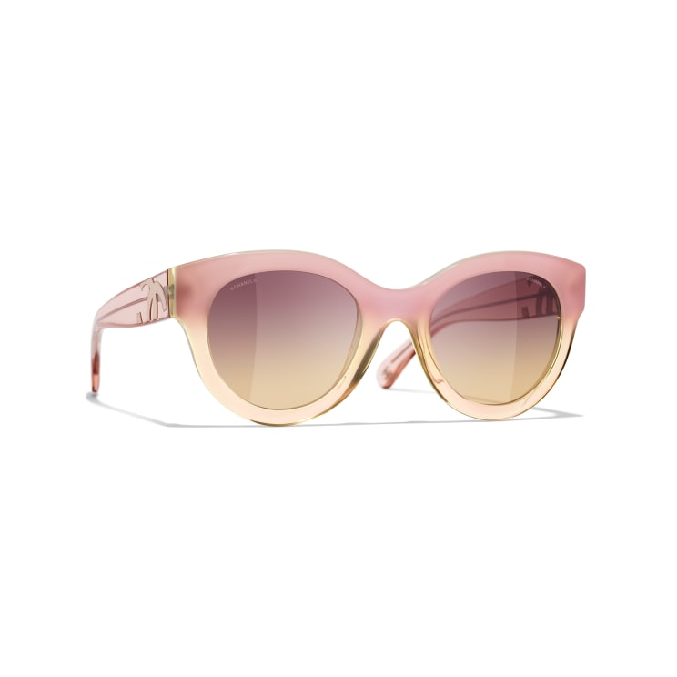3. Butterfly Pink Sunglasses*

*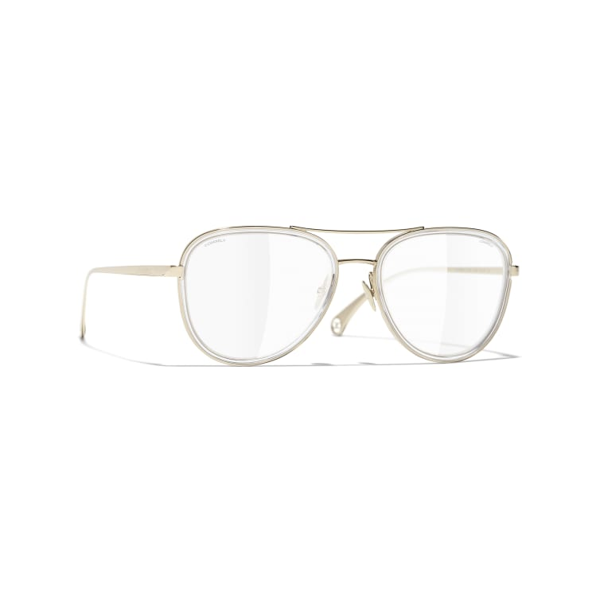4. Pilot Sunglasses*

*Made of Gold metal to give out that on point look*

1. *PERSONALIZED GIFTS*
   1. *PERSONALIZED Mugs*

*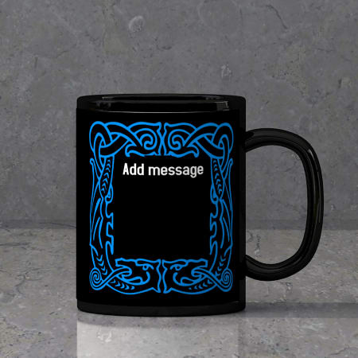*

*Personalized mugs come in various categories and are to be customized according to customers liking.*

* 1. *Personlaized Cushions and Pillows*

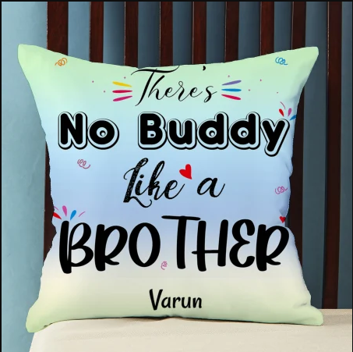

1. *No BUDDY LIKE A BROTHER*

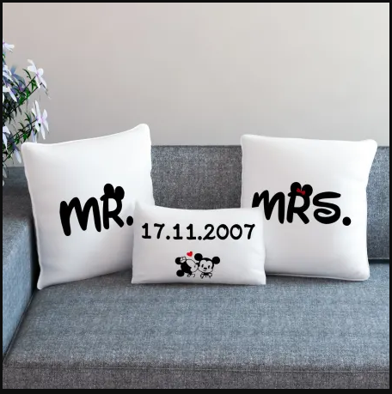

1. *MR , MRS Personalized Cushions.*

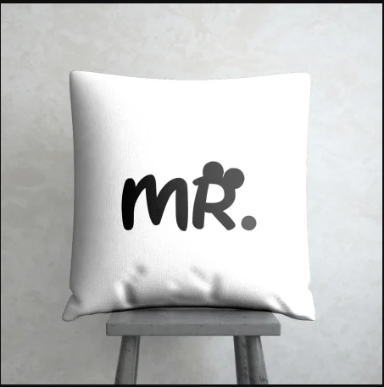 *3. MR Cushion.*

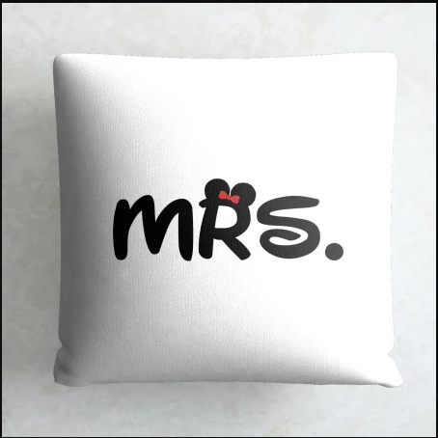 *4. Mrs Cushion*

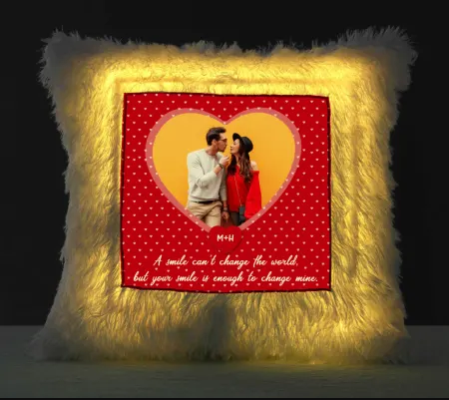

*5.Personalized Your smile is love LED Fur cushion.*

1. *ROSES.*
   * + 1. *Pink Roses*

*A.)Bunch of 20 roses.*

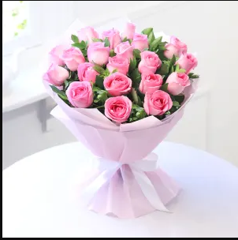

*b.) bunch of 50 pink roses*

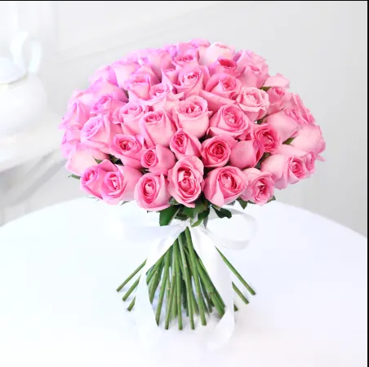

*c.)Elegant pink roses in a basket*

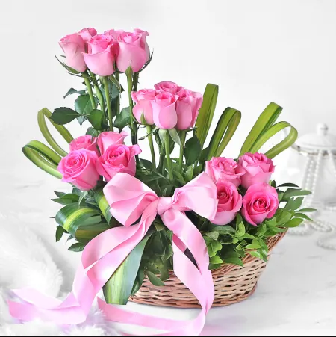

d.)Pink roses bouquet with a pink ribbon

*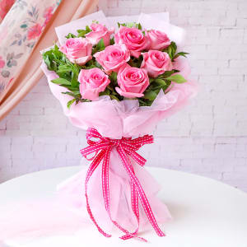*

*e.) A bouquet of Pink roses with chocolate*

*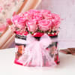*

* + - 1. *RED ROSES*

*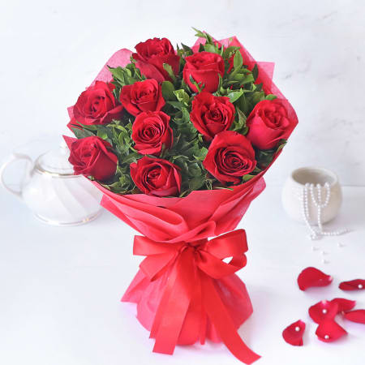a.) Bouquet of Red Roses*

*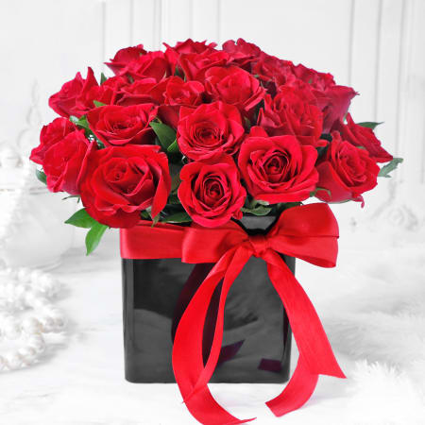b.) Bouquet of Red roses with in a black vase with a red ribbon*

*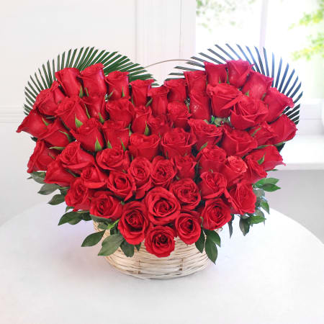c.)*

*Love shaped boquet of red roses*

*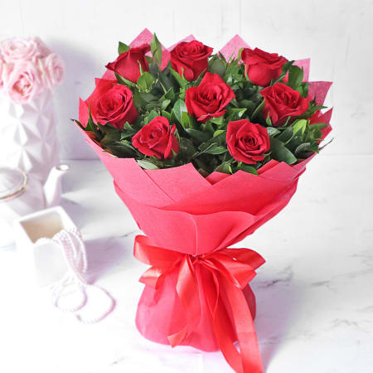*

*d.) A bouquet of 8 red roses in a red Vase*

*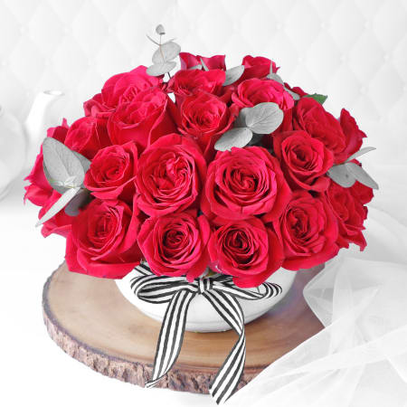*

*e.) A boquet of red roses with a white ribbon in a grower*

*4. CHOCOLATES*

*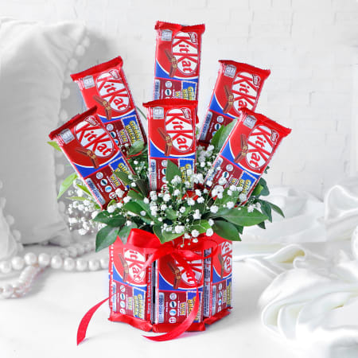 a.) KitKat chocolates*

*b.) Salty and Nutty Chocolate*

*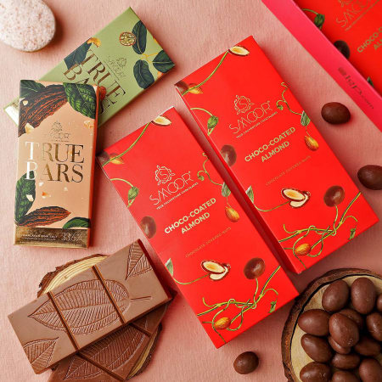*

*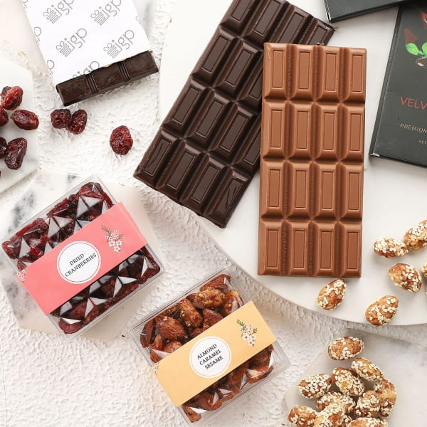*

*c.) Delicious Healthy Gift Pack*

*d.) Personalized Key holder plus a bar of chocolate*

